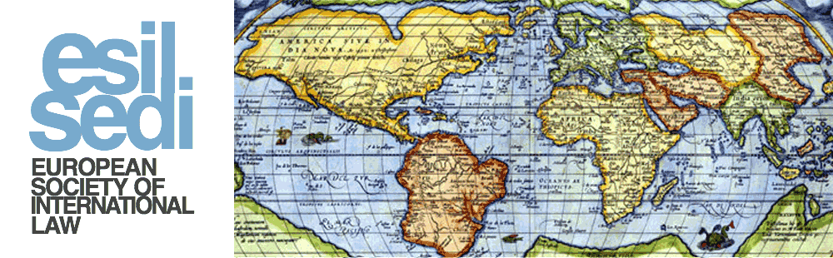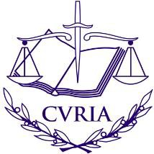

ESIL – CJEU SYMPOSIUM

Adjudicating the International Responsibility of the EU
Friday 14 June 2019
Court of Justice of the European Union, Luxembourg

13:45 Registration

14:00 Opening

Koen Lenaerts, President, Court of Justice of the European Union
Luis M. Hinojosa-Martínez, President, European Society of International Law

14:15 Keynote opening speech

Pieter Jan Kuijper, Professor, University of Amsterdam

14:45 Session I: Investor State Dispute Settlement

Chair: Hélène Ruiz-Fabri, Professor, Max Planck Institute, Luxembourg

Speakers:

Stephan Schill, Professor, University of Amsterdam
Marko Ilešič, Judge, Court of Justice of the European Union

16:15 Coffee Break

16:30 Session II: EU International Responsibility

Chair: Koen Lenaerts, President, Court of Justice of the European Union

Speakers:

Ramses Wessel, Professor, University of Twente
Allan Rosas, Judge, Court of Justice of the European Union

18:00 Reception

To register for this event: please send an email to events@curia.europa.eu with your name, affiliation, and your identity card/passport number. The deadline for registration is 3 June 2019.

