ESIL Interest Group on Peace and Security – Annual Report 2019

- The Conveners: Some Continuities, Some Excellent Additions
Besides Nicholas Tsagourias (Professor of International Law and Director of the Sheffield Centre for International and European Law) and Paulina Starski (Visiting Professor at the Humboldt University Berlin/Senior Research Fellow at the MPI for Comparative Public and International Law) who have already served as conveners for the last years, the Interest Group gained some fresh wind with two excellent additions: Clare Moran Francis and Ilja Pavone.

Clare Frances is lecturer in law at Edinburgh Napier. Her research interests lie in the related of international criminal law, international humanitarian law, and international human rights law, with a focus on the application of legal theory to these areas. Her current work focuses on a theory of authority in international criminal law, and is due to be published by Cambridge University Press in 2020. She has published widely on the concept of defences in international criminal law and responsibility for international crimes, particularly in relation to non-state actors.

Ilja Richard Pavone gained his PhD in International Law and Human Rights at Sapienza University, Rome. He is member of the EU Non-Proliferation and Disarmament Consortium. In the past, he has taught at the universities of Rome (Sapienza), Venice (Venice International University), Macerata and Siena. He has been Visiting Professor abroad at several universities and research institutions (for instance, Queensland University, Bochum University and Max Planck Institute for Comparative Public Law and International Law, Heidelberg). He is author of over fifty publications, essays and articles in International Law and European Union Law, with a particular focus on Human Rights Protection, Nuclear Disarmament, Bioethics, Animal Law, International Health Law and Environmental Protection.

- ESIL Research Forum in Göttingen: IG Peace and Security Side Event – “The Rule of Law in Cyberspace”

The Interest Group organized a workshop during the ESIL Research Forum in Göttingen on 3 April 2019 on the “Rule of Law in Cyberspace”. Five early-career scholars were given the opportunity to present on their research. The workshop covered such diverse topics as “Whose law rules in cyberspace? On (extra-)territorial jurisdiction over global data flows” (Przemysław Roguski, Jagiellonian University in Krakow, Poland), “Multinational corporations and the rule of law in cyberspace” (Stephan Koloßa Ruhr University Bochum, Germany), “Cyber attacks, corporate liability, and the right to privacy: A view from China, by drawing on the Cathay Pacific crisis” (Riccardo Vecellio Segate, PhD Researcher in International Law, Faculty of Law, University of Macau), “Cyberspace and Artificial Intelligence: from a- territorial space to a-territorial “beings” and the role of human rights for an adjusted version of rule of law” (Themis Tzimas, University of Macedonia, Greece) and “‘Hacking Back’ and the Uneasy Place of Necessity within the Rule of Law” (Henning Lahmann, Senior Researcher Digital Society Institute, Berlin, Germany). The presenters received comments by Andreas Kulick (Eberhard-Karls University Tübingen), Irene Couzigou (University of Aberdeen) and Nicholas Tsagourias. The workshop stimulated a vibrant debate. The individual contributions as well as a general conceptual article by Nicholas Tsagourias and Paulina Starski are planned to be published in a special issue of the Heidelberg Journal for International Law in spring 2020.

- New Website and New Twitter Account

The IG has a new online presence (https://igpeaceandsecurity.wixsite.com/esiligps).

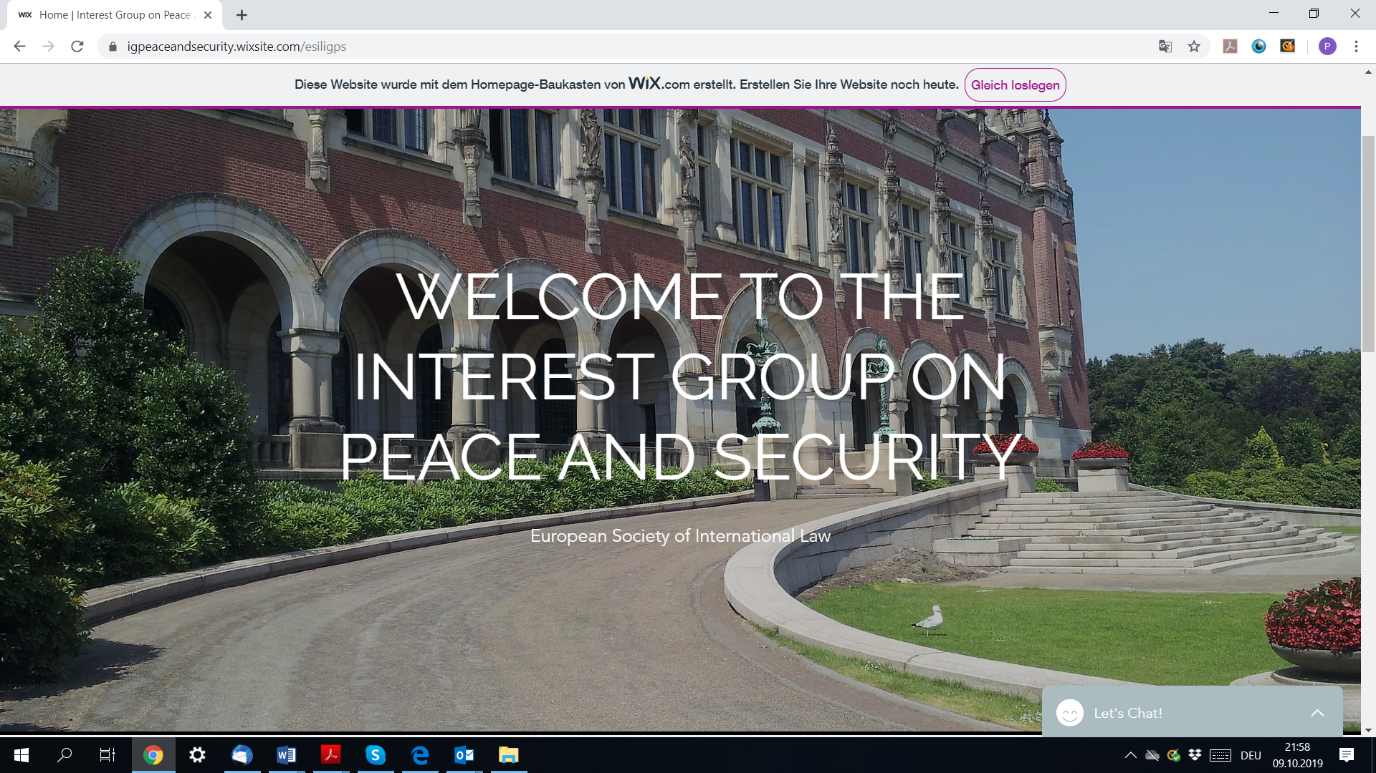

It is designed to give group members the opportunity to present their research and hence to stimulate the discourse within and outside the Interest Group.

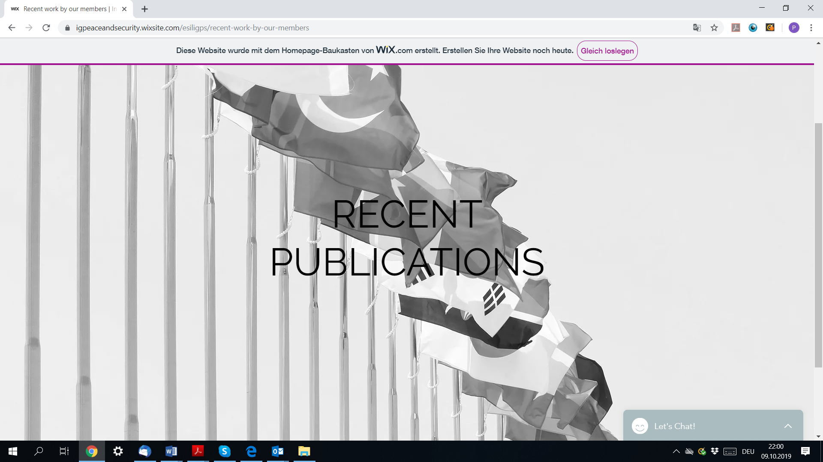

It does also serve as a platform to communicate group events.
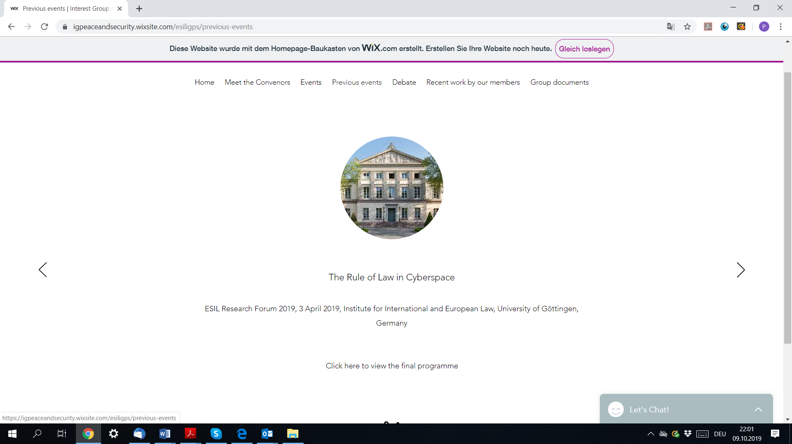

The Interest Group has also set up its own Twitter account and will take advantage of it in order to communicate with group members, scholars and the general interested public.

- Outlook: ESIL Research Forum in Catania

Currently the Interest Group is preparing a Call for Papers for the ESIL Research Forum in Catania. It will be online soon.

